CLASS X

GUESS PAPER

FIT

1. Draw the XML tree for code given below:- 5

<BANK>

<ACCOUNT>

<SAVING>

<MANAGER>Mr. Ratan Rao</MANAGER>

<CLERK>Mr. Sandhu Sinha</CLERK>

</SAVING>

<CURRENT>

<MANAGER>Mrs. Reeta Kour</MANAGER>

<CLERK>Mr. Amit Nag</CLERK>

</CURRENT>

</ACCOUNT>

</BANK>

2. Differentiate between the XML and HTML. 2

3. **Attempt any one question out of the given two:** 5

A. Sahiba, a website designer with “International Designers Pvt. Ltd.” has written the following code. Observe the code given below and answer the following questions:

<company>

<employee eid=1>

<name>Albert</name>

<dept deptid=“d1”>Computer</dept>

</employee>

<employee eid=2>

<name>Manisha</name>

<dept deptid=“d2”>Accounts</dept>

</employee>

</company>

i. Are these tags part of HTML code or XML code?

ii. Identify the root element.

iii. Mention any two child elements.

iv. Mention any two attributes.

v. An xml document can have more than one root element. Is it true or false?

**OR**

B. Vani, a class X student has recently completed her HTML course and just started learning XML. Help her in the following:

i. Mention her any one main difference between HMTL and XML.

ii. She has been told that “All major browsers have a built-in XML parser to access and manipulate XML”. Is this statement right or wrong?

iii. Explain her the purpose of comments in XML document.

iv. Tell her the syntax to put comments in XML documents.

v. Explain her the meaning of well-formed XML documents.

4.I) Write the HTML code to generate the following output:- 5

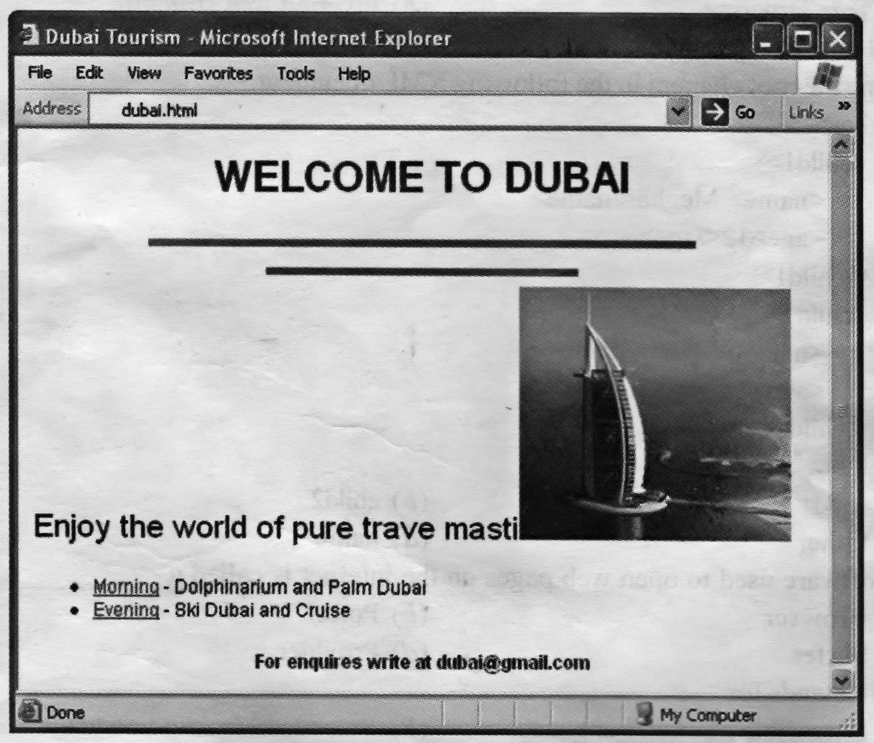

Note the following points while generating the web page:-

i) **Title** of the page should be “Dubai Tourism”

ii) The heading text “Welcome to DUBAI” is in Arial font and is **maroon** color.

iii)The horizontal lines below heading are 8 pixels thick and of blue color.

iv) Image used in the page is dmps.jpg.

v) The bulleted list contains links as specified below:

- the text Morning is a link to the “morning.html”

- the text Evening is a link to the web page “evening.html”

II) Write the HTML code to generate the following web page with the given below specifications

(a) Bordered table should have background color in pink.

(b) Table’s header row with a heading “INCOME TAX SLABS 2017-18” should spread over

four cells.

(c) After heading row, first cell of next row should spread over five rows with an image named

“it.jpg” stored in d: drive.

(d) Set the space between the cell wall and the cell content to 10 pixels and set the space between

the cells to 10 pixels.

(e) At the bottom of the page, a link to next page is there which is linked to another webpage

named “next.html”.



5. Multiple choice questions:- **1 mrk each**

i) Which of the following is an attribute of <Table> tag?

a) SRC b) LINK c) CELLPADDING d) BOLD

ii) Which is the correct HTML tag for the largest heading?

a) H1 b) H2 c) H4 d) H6

iii) Which tag is used to make the text bold?

a) <B> b) <Bold> c) <Strong> d) Both a) and c)

iv) The symbol used at the beginning of the HREF text is

a) # b) $ c c) & ss d) ^

v) Data recovering means

a) Transfer of data b) Storage of data

c) Getting back the lost and inaccessible data d) Getting back the storage device

vi) Which one of the following is an e-Shopping website:

i) Flipkart ii) Amazon iii) Snapdeal iv) All of above

vii) Background is an attribute of:

i) <BODY> tag ii) <FONT> tag iii) <IMG> tag iv) <A> tag

vii) A link used to navigate or open other web pages on a website on internet is called:

i) Higherlink ii) Hyperlink iii) Heterolink iv) None of above

ix) A total of how many headings are there in html:

i) 4 ii) 6 iii) 7 iv) 8

x) Which one of the following is not an attribute of <A> tag:

i) NAME ii) HREF iii) Source iv) Both (i) & (ii)

6. Answer the following questions:- **1 mrk each**

a. What is the action of Back button?

b. Name any one Web Browser.

c. What is the full form of URL?

d. Name the protocol which is used for uploading & downloading data from remote site.

e. Name any one Antivirus Software.

f. Discuss the purpose of HTTP briefly.

g. What is the action of Refresh button?

h. What is Blog?

i. Tamanna needs to store and transport the data. She should use HTML or XML?

e. What is Social Digital Divide?

7. Answer the following questions:- **2 mrks each**

a. Define container & empty tags in HTML.

b. What is a primary key in tables? Explain with the suitable example.

c. What is the need of a database? Discuss briefly.

d. What is the purpose of an Anti virus? Give the name of any two popular Anti Virus software.

e. Define Video Conferencing.

f. Define cell padding and cell spacing with respect to tables in HTML.

g. Explain all attributes of *List tag*.(with syntaxes)

h. What do you understand by DBMS? Explain with examples.

8. Long answer type questions:- **3 mrks each**

a. What is the purpose of <IMG> tag? Mention it’s any two attributes along with their purpose.

b. Ishan, a trainee in a multinational bank has just got his first official computer with internet facility in his office. Explain him about Malware, its types and any two precautionary measure he should be taken for information security.

c. Differentiate between <UL> and <OL> tags with suitable examples.

d. What is e-Learning? Mention any two main benefits of e –learning with respect to the use of Information Technology.

e. Differentiate between <TR> and <TD> tags with suitable examples.

f. Differentiate between Crackers & Hackers.

g. What is the purpose of <IMG> tag? Mention it’s any two attributes along with their purpose.

h. Your father is a business holder who does his business through Internet. He manages his transaction through e-commerce technology. Today, a lots of security threats are procuring over Internet. State few points that how can he minimize the security threats over e-commerce?

**Written By**

**Kavita Singh**

***e-mail id: singh_kavita1@rediffmail.com***